Dine to Donate
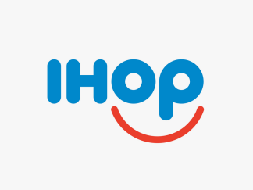

IHOP Lexington Park is teaming up with Saint John’s Catholic School for a Spirit Night.

Wednesday- August 17th
3:00 PM – 10:00 PM

**Bring in this flyer during this time, have dinner, and IHOP will donate back a portion of their sales to St. John’s Catholic School.**

